Usability Report

Indiana Daily Student

INFO-I 360

Max Leitgeb

Introduction

For my usability report I will be reviewing the *Indiana Daily Student*. This report will help recognize potential problems within the IDS and in turn offer recommendations for enhancing its performance. I will be conducting three usability tests to gauge the user’s behavior and take note of any issues with the presented content. These tests are conducted to help enhance the user experience and review the steps the user takes to complete the given tasks.

Research

After taking time in class reviewing the *Indiana Daily Student* along with other colleges news sites, I have noticed potential changes that the IDS could apply from other sites. I have selected six university news websites that I believe represent a good online newsletter.

* <https://www.collegian.psu.edu/> Penn State University
* <https://thedailytexan.com/> University of Texas
* <https://www.dukechronicle.com/> Duke University
* <https://yaledailynews.com/> Yale University
* <https://www.michigandaily.com/> University of Michigan
* <https://www.idsnews.com/> Indiana University

The above websites rank among the top in the nation when it comes to collegiate newsletters. Each of the six websites have a similar layout, with the navbar located at the top of the page with similar categories for each university. One main difference that I noticed between the IDS and the other sites is that they have a call to action at the top of their page to get the user to visit their social medias. In order to find the IDS social medias, you must scroll to the bottom of the page. Another large difference is that some of the websites also include a subscribe button at the top of the page. While one may think this is the most important call to action for a newsletter, the IDS also has the subscribe button located at the bottom of the page.

After this review, I selected to do my report on the IDS as it could use some modifications to be on the same level as some of the top online newsletters in the nation. The IDS reflects some qualities shown in the other sites but could be altered to help improve usability. One main issue is the cluttered layout as it can make for complicated navigation for the user. The following user tests reflect issues on the website along with providing some insight on what could change to help improve the usability.

Analysis

The IDS website poses many areas for improvement. One main issue is the clustered layout of the articles being presented. This crowded layout can make for difficult navigation and confuse the user. The navigation bar does not help make searching through the site easier, as it is not clear what is being presented on each page and provides the user with too many subjects to ponder. Another issue I found to be prevalent was the location of the multiple calls to action. A college news site should prioritize getting subscribers and plugging their social medias, although these are located at the bottom of the page, out of sight of the user. However, the support us button is located at the top of the page, which leads the user to a page that is not clear on the exact steps to take to help support them. The overall design could be changed to resemble Indiana University more, along with looking more like an online newspaper as well. The three issues I am going to be focusing on are the layout, navigation, and call to action.

Firstly, the layout could be altered in many ways to appear more pleasing to the human eye. For example, the text hierarchy could be changed to highlight what is important for the user to notice. The titles of certain articles are very similar to some article headings, not only in the size, but they also carry the same bold weight. While there is somewhat of a flow within the website, it is hard to tell where sections are being represented along with the confusing hierarchy I mentioned earlier.

Next, I will discuss the navigation of the website. The problem with the navigation begins with the navigation bar, as it is not clear what will be in each topic, and why it is aligned the way it is. Another major problem I found with navigation was locating the social media links and how to subscribe. Once the user does find the subscribe link, it is a brand-new page that has separate layout from the IDS website and cannot navigate back to the homepage without pressing the back button.

Lastly, I will discuss the call to action. Throughout my research, I found the most important call to actions to be getting the user to subscribe, and for them to follow the socials of the news page. All of the other college websites I reviewed included the links to the social media pages at the top of the page, in clear sight of the user when they are on the home page. It was also common practice to put the subscribe button at the top of the page. However, these two are located at the bottom of the page for the IDS and make for a confusing call to action that only appear to be the Support Us button.

User Backgrounds

For my user tests, I selected three college students at Indiana University with different skills in tech and computing. The majors of my subjects are Computer Science, Informatics, and Global Policy. One of my users has visited the site before, whereas the other two had never been on the site. Each test took around 15 minutes and helped find usability issues within the website.

Key Findings

The first usability issue I tested was within the navigation. I started by asking the users to navigate to a topic of their interest, which they did easily using the navigation bar, although two of them started by looking at the headline articles rather than the navigation bar. The third user navigated to the classifieds page, looking for things for sale from IU students, but came across a layout issue. As shown in figure 1, the content the user was looking for is not what appeared and instead was a somewhat blank website.

*Figure 1: User did not see any listings.*

This area could clearly be improved by leading the user to a more relevant page.

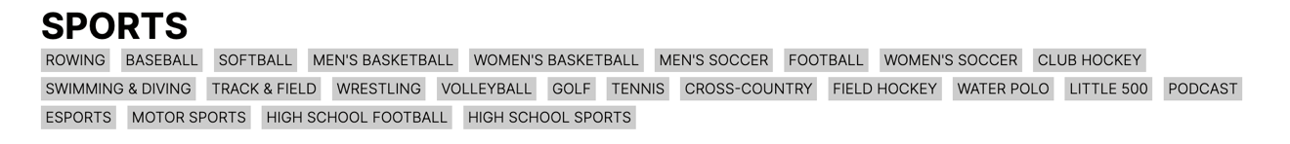

*Figure 2: Text is small and does not alert any importance to the user.*

One of the users I tested started by clicking on the sports page, but then realized there was too much varying information, and wanted to see information on solely the football team. The user missed the navigation option presented in figure 2 as the information presented is small and easy to skip past. The user instead went back up the navbar to find the football page.

*Figure 3: Social Media links located at bottom, but the users expected to find them near the top.*

I asked the users to find the social media links and the subscribe button on the page, which took them some time as it is located at the bottom of the page. When the users did reach this part of the page, they still struggled somewhat to find the links as they were looking for text that said “Instagram” or “Follow Us” rather than the icons. This issue also plays into the problems with the layout of the page, as the users thought that they would be located near the top.

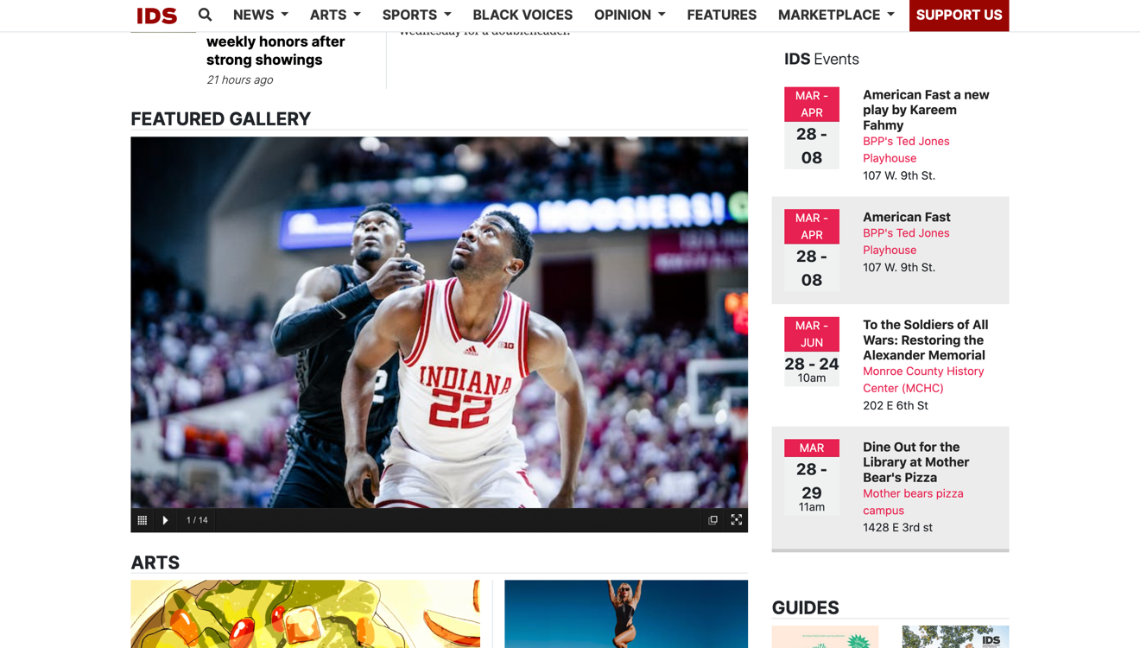

*Figure 4a: Solid use of grid system, not much white space presented.*

*Figure 4b: Directly below figure 4a, large white space created on the right side of the page.*

Another issue that was mentioned by multiple of my test subjects was the sudden white space that appears as they were scrolling down the page. The users mentioned that the information stopped following the same layout that it had been throughout the rest of the page and there was a blank part of the site that could be used.

*Figure 5: All headlines are the same color and weight, and many articles do not have descriptions outside of the headline.*

One of the users also mentioned that the articles pictures on the site could use small descriptions, and that changing the color of the text could help make the hierarchy more obvious.

The last issue I explored was with the call to action. While the Support Us button is clearly pictures, it is not obvious what it does, and users may argue that social media links and the Subscribe button are more important calls to action.



*Figure 6: The Support Us button is appropriately positioned, but it is not obvious what it does.*

One of the users I tested attempted to subscribe to the newsletter by clicking the Support Us button, but this is located with a different button at the bottom of the page. All of the users I tested expected the Subscribe button to be located at the top along with the social media links.

Conclusion

I conducted this test with the purpose of critiquing the Indiana Daily Student and finding issues that someone who is not familiar with web design may notice. With my research I found some issues that are prevalent on the IDS website that are constructed better with other colleges websites. While the IDS is a great website with a multitude of information, sometimes there are small changes that could make the website all that much better. I think that with future iterations of the website the designers can think more about how to make the website user-friendly, rather than simply trying to present as much information as possible. Along with this, I think it could be beneficial to evaluate what the most important parts of the website are and what the most effective way of presenting them would be. I think that with any future changes, user testing is a great way to find any hidden issues or small things that could be altered to fix the websites usability.

Addendum: Testing Notes

Have you visited this site before?

1. No
2. No
3. Yes

What do you think the purpose of this site is before accessing it?

1. Events going on on-campus.
2. Student News and Events.
3. IU Students News.

Navigate to the Home page. What do you think the most important content is?

1. Recent News/Events (based on the largest article pictured).
2. News.
3. The large articles in the middle of the page.

Now navigate to a topic that you are interested in. What is the topic and is the displayed information what you were looking for?

1. Navigated to the men’s basketball section. The user found articles in relation to what they were searching for.
2. Navigated to the sports section and then attempted to navigate to the football page, which took a bit of time.
3. Navigated to the classifieds section. The information was not what they were looking for as they wanted to see things for sale from IU students.

Can you navigate to the IDS social media links? Is this where you expected them to be? How difficult was it to find this information?

1. The social media links are not where they expected them to be. Started search at the top of the page and was looking through each of the tabs for Instagram before scrolling all the way down and eventually finding the link. Rated it extremely difficult to find the links.
2. Clicked the support us button. Scrolled to the bottom and eventually found the links after some searching. Rated it neither difficult, nor easy.
3. Started by looking at the top drop-down menus. After quickly noticing it was not up there, they scrolled to the bottom and quickly found the links. Rated it neither difficult, nor easy.

You want to subscribe to receive updates from the newsletter. How would you go about doing this?

1. Clicked the support us button. Eventually found their way at the bottom to find the subscribe button.
2. Saw the subscribe button while looking for the social media links and knew where to click.
3. Saw the subscribe button while looking for the social media links and knew where to click.

Now that you have accessed the subscribe page, are you able to return to the IDS home page?

1. Had to click the Google back button.
2. Had to click the Google back button.
3. Had to click the Google back button.

Does the homepage present information well? Please speak on the hierarchical way the information is presented and what it represents.

1. Overall solid flow but believes that the pictured articles appear cluttered on the page and can create for confusing navigation.
2. Information is not presented well, and they are confused on what is an article and what is not.
3. No, the ad at the top of the screen takes up too much space. Navbar is poorly weighted as they believe some of the topics can fit under the news tab.

What would be one change that you would make to this site?

1. Spread out the articles and separate the topics in a cleaner way (Mentioned that color changes could help with the displaying of information and articles).
2. Change the banners at the top and the middle of the page to more represent IU and make navigation easier.
3. Rethink the topic choices at the top of the page (Sports can be considered news so it should fit under the news tab).

Addendum: Reflection Question

**How successful were you at creating tasks / scenarios for each usability issue?**

One issue I came across with creating tasks was finding how to test the user without making them repeat what they have already done. I would say it took a bit to come up with the tasks, but I believe I had good questions that helped me receive information in different areas.

*Did your tasks help to illustrate whether or not the issue was there? Do you wish you had written any of them differently?*

I believe my tasks helped illustrate the issue, but some could have been altered to get a clearer response. If I were to conduct another user test, I would make my questions more precise and encourage the users more to speak out on any thoughts they have.